**CSE4003 Human Computer Interaction: Assessment 3- Benjamin Smerd 22072922**

**Abstract**

This report compares the Bubble Cursor with the Normal Cursor in a target selection task. Participants completed trials under different widths, distances, and distractor numbers, with data collected on movement time, errors, and subjective ratings. Results showed that the Bubble Cursor was faster, more accurate, and preferred by participants. Fitts’ Law analysis confirmed both cursrors followed the predicted linear trend, with the Bubble Cursor showing less task difficulty.

**Introduction**

Pointing and selecting targets is a common action done by humans on computers, but performance can vary depending on target size, distance, and distractors. The Normal Cursor is widely used but often struggles in harder conditions. The Bubble Cursor was developed to improve this by dynamically resizing its clickable area to reach to the closest target.

This study aimed to test whether the Bubble Cursor performs better than the Normal Cursor in terms of speed, accuracy, and user preference. Based on prior research, it was expected that the Bubble Cursor would reduce movement time and errors, and be preferred by participants. Fitts’ Law was also used to evaluate how each cursor responded to increasing task difficulty.

**Experiment**

The independent variables in this experiment were the cursor type (Normal vs Bubble), target width, target distance, and the number of distractors. These factors were chosen because each can influence how quickly and accurately a user can move the cursor to a target.

The dependent variables were movement time (measured in milliseconds) and error rate (the number of incorrect selections). These measures have an accurate reflection on the efficiency and accuracy of each cursor type under the different task conditions provided above.

The study used a within-subjects design, meaning that every participant experienced both cursor types under all conditions. Each participant completed three blocks of trials with the Normal Cursor and three blocks with the Bubble Cursor. Within each block, conditions were varied across target width, distance, and distractor number. Each condition was repeated twice, giving six trials per condition for each participant.

In total, six participants took part in the study. The within-subjects design ensured that all participants were testing to the full range of conditions. This helps to balance out individual differences and reduce the potential order effects that can happen when not controlled with counterbalancing.

**Data Analysis**

**Learning Effetcs**

**Statistical Summary**

Calculated and display statistical results. We can split the data into 6 groups- BubbleCursor + block 1, BubbleCursor + block 2, BubbleCursor + block 3, NormalCursor + block 1, NormalCursor + block 2, NormalCursor + block 3. We calculate the time for each group based on the field ‘Time’ as this was the dependent variable analysed.

* ‘N’ refers to the number of trials in that group.
* ‘Mean’ represents the average movement time in ms.
* ‘SD’ represents the standard deviation.
* ‘SE’ represents the standard errors.
* ‘95% Conf. Interval’ means 95% confidence interval.

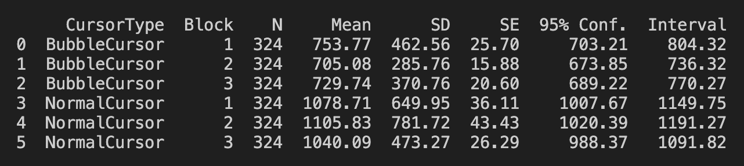

***Normal Cursor***

**AnovaRM**

Learning effect analysis for Normal Cursor.

* The F test-statistic is 0.8330
* Corresponding p-value is 0.4628
  + Since p value is greater than 0.005 we conclude there are no main effects on task time for blocks- block has no effects on task time
* ‘Num DF’ represents the degrees of freedom for the model, which equals the number of Block levels minus one (3 – 1 = 2).
* ‘Den DF’ represents the degrees of freedom for the denominator (within-subject variance), calculated as (number of Blocks – 1) × (number of participants – 1) = (3 – 1) × (6 – 1) = 10.

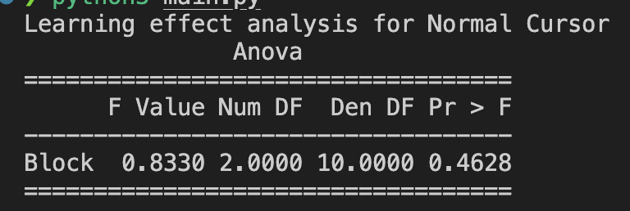

**Post-hoc test**

For the Normal Cursor condition, blocks did not have a significant main effect on task time (F(2, 10) = 0.83, p = 0.46). The mean time for Block 1, 2 and 3 was 1079 ms, 1106 ms and 1040 ms respectively. Pairwise comparisons with the Bonferroni correction revealed no significant differences between each two blocks (all p > 0.14). Therefore, we used the data of all blocks in the rest of data analysis.

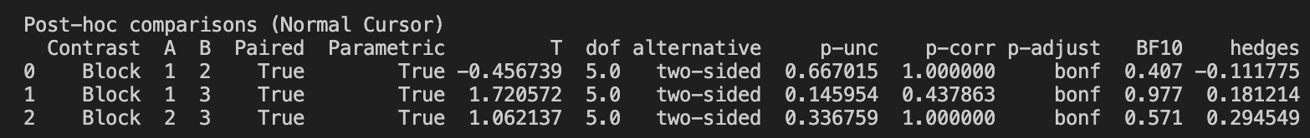

***Bubble Cursor***

**AnovaRM**

Learning effect analysis for Bubble Cursor.

* The F test-statistic is 2.0872
* the corresponding p-value is 0.1748
  + Since this p-value is greater than 0.05, we conclude that there are no significant main effects of Block on task time- block does not affect task time.
* ‘Num DF’ represents the degrees of freedom for the model, which equals the number of Block levels minus one (3 – 1 = 2).
* ‘Den DF’ represents the degrees of freedom for the denominator (within-subject variance), calculated as (number of Blocks – 1) × (number of participants – 1) = (3 – 1) × (6 – 1) = 10.

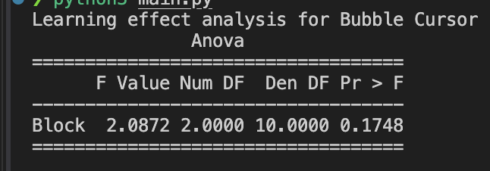

**Post-hoc test**

For the Bubble Cursor condition, blocks did not have a significant main effect on task time (F(2, 10) = 2.09, p = 0.17). The mean time for Block 1, 2 and 3 was 754 ms, 705 ms and 730 ms respectively. Pairwise comparisons with the Bonferroni correction revealed no significant differences between each two blocks (all p > 0.15). Therefore, we used the data of all blocks in the rest of data analysis.



**Dependent Variables- Time**

**Summary**

These results suggest that the Bubble Cursor enabled faster pointing performance on average compared to the Normal Cursor from looking at the mean. However, statistical analysis (repeated measures ANOVA) is required to determine whether this difference is significant.

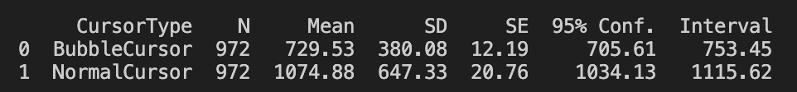

**AnovaRM- Task analysis on dependent variable**

Task time showed significant main effects of Cursor Type (F(1, 5) = 57.25, p < 0.001), Target Width (F(2, 10) = 29.10, p < 0.001), and Target Distance (F(2, 10) = 43.07, p < 0.001). The Bubble Cursor was faster than the Normal Cursor, larger targets were selected more quickly, and longer distances increased task time. Distractor Number was not significant (p = 0.10).

Significant interactions were found for Cursor Type × Target Width (F(2, 10) = 36.17, p < 0.001), Cursor Type × Distractor Number (F(2, 10) = 5.24, p = 0.028), Target Width × Target Distance (F(4, 20) = 3.53, p = 0.025), and a three-way interaction of Cursor Type × Target Width × Target Distance (F(4, 20) = 2.97, p = 0.045). These results indicate that the Bubble Cursor advantage was strongest with smaller targets, longer distances, and more distractors.

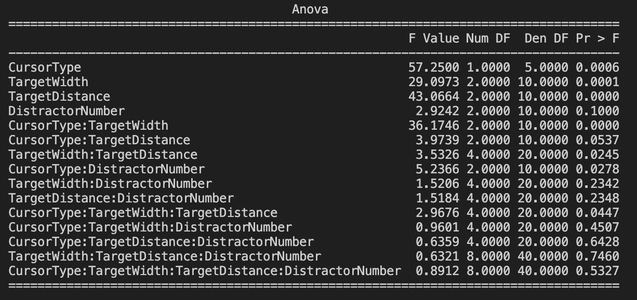

**Data Visualisation**

Cursor type had a significant main effect on task time (F(1, 5) = 57.25, p < 0.001). The mean time for the Bubble Cursor and Normal Cursor was 730 ms and 1075 ms respectively. There was a significant interaction effect between cursor type and target width (F(2, 10) = 36.17, p < 0.001). The performance difference between Bubble and Normal Cursor increased as target width decreased, with the Bubble Cursor showing the greatest advantage for small targets. However, the distractor number did not have a significant main effect (F(2, 10) = 2.92, p = 0.10).

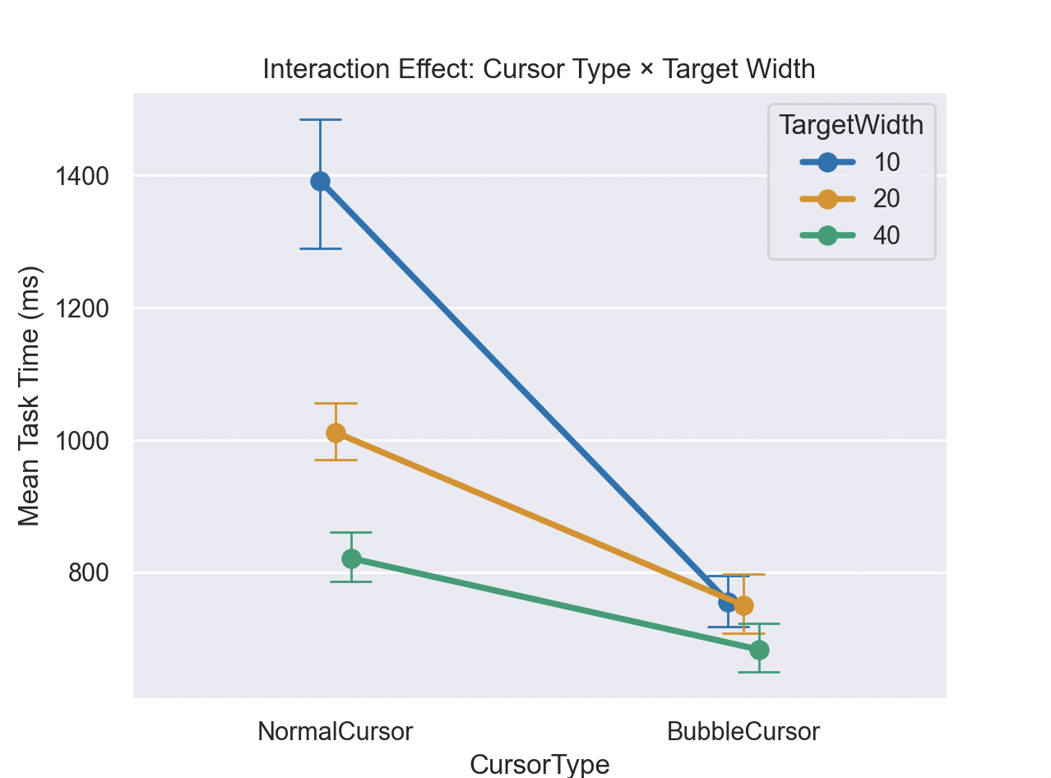

**Dependent Variables- Errors**

**Summary**

We calculated descriptive statistics for error rates grouped by cursor type. The Bubble Cursor had a mean error rate of 0.11 (SD = 0.35), while the Normal Cursor had a mean error rate of 0.21 (SD = 0.55). Standard error values were 0.01 for Bubble Cursor and 0.02 for Normal Cursor, with 95% confidence intervals of [0.09, 0.13] and [0.17, 0.24] respectively. These results suggest that the Bubble Cursor reduced errors on average compared to the Normal Cursor. However, statistical analysis (repeated measures ANOVA) is required to determine whether this difference is significant.

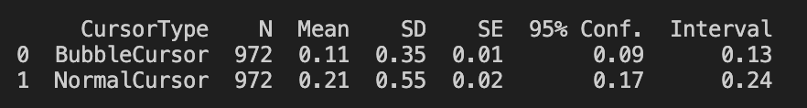

**AnovaRM- Task analysis on dependent variable**

Error rate showed significant main effects of Cursor Type (F(1, 5) = 26.97, p = 0.004), Target Width (F(2, 10) = 5.62, p = 0.023), and Target Distance (F(2, 10) = 5.42, p = 0.026). The Bubble Cursor produced fewer errors than the Normal Cursor, smaller targets led to more errors, and longer distances increased errors. Distractor Number was not significant (p = 0.92).

Significant interactions were found for Cursor Type × Target Width (F(2, 10) = 8.88, p = 0.006) and Target Width × Target Distance (F(4, 20) = 3.83, p = 0.018). These results indicate that the Bubble Cursor advantage was strongest for small and distant targets, where the Normal Cursor showed more errors.

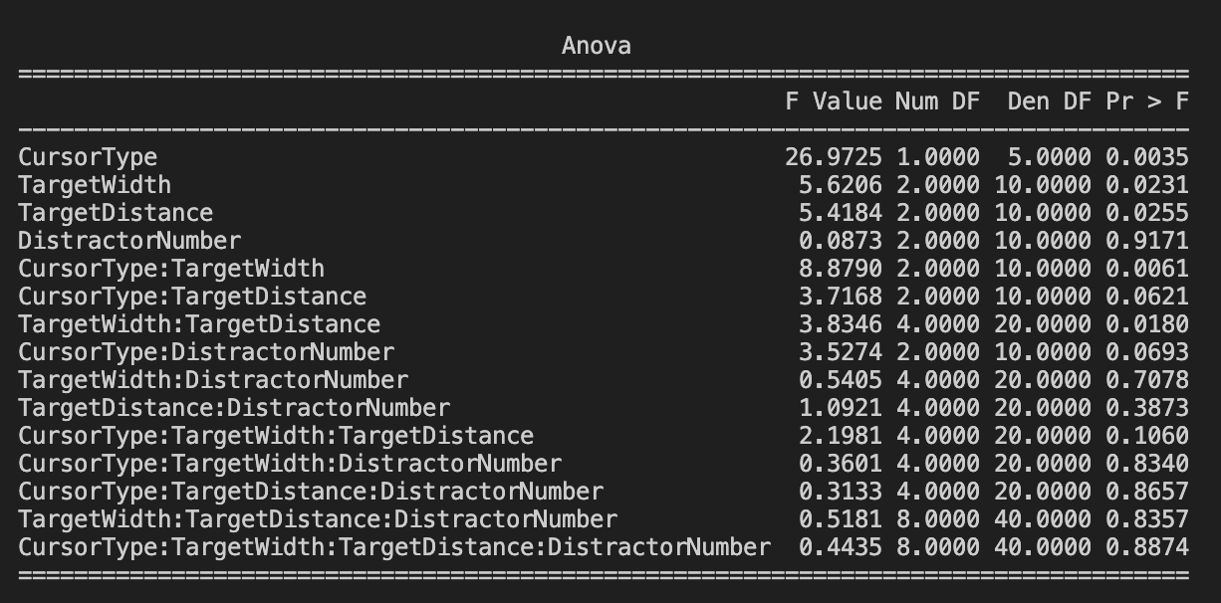

**Data Visualsation**

A line plot of Cursor Type × Target Width (see Figure X) showed that the Bubble Cursor consistently reduced errors compared to the Normal Cursor. For the Normal Cursor, error rate increased sharply for small targets, while for the Bubble Cursor error rates remained relatively stable across widths. This pattern confirms the significant interaction found in the ANOVA, indicating that the Bubble Cursor was particularly effective at reducing errors when selecting small targets.

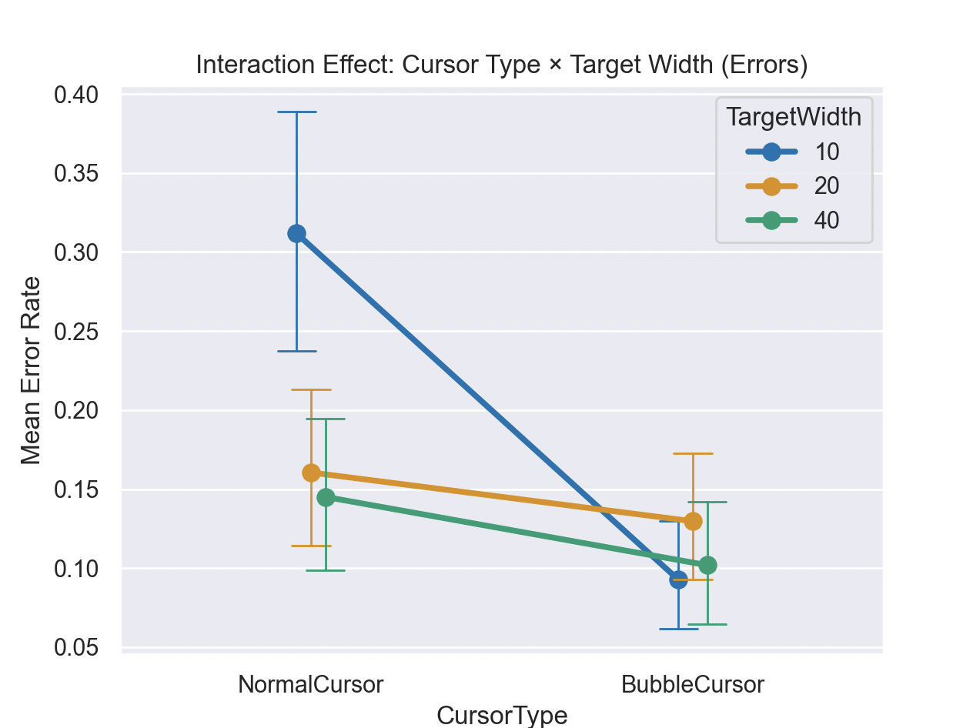

**Subjective Feedback**

**Summary**

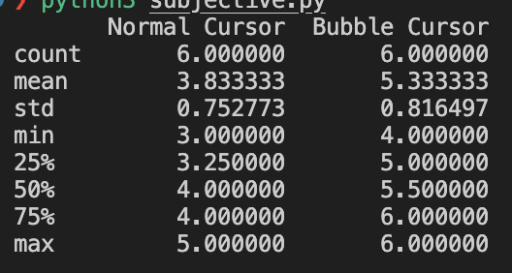

**Wilcoxon Result**

The Bubble Cursor had significantly higher subjective ratings of preference than the Normal Cursor (z = 0.0, p = 0.031). The mean rating for the Bubble Cursor was 5.33, compared to 3.83 for the Normal Cursor. This indicates that participants preferred using the Bubble Cursor.



**Fitts Law**

Display equation on chart and display R-squared value on the chart.

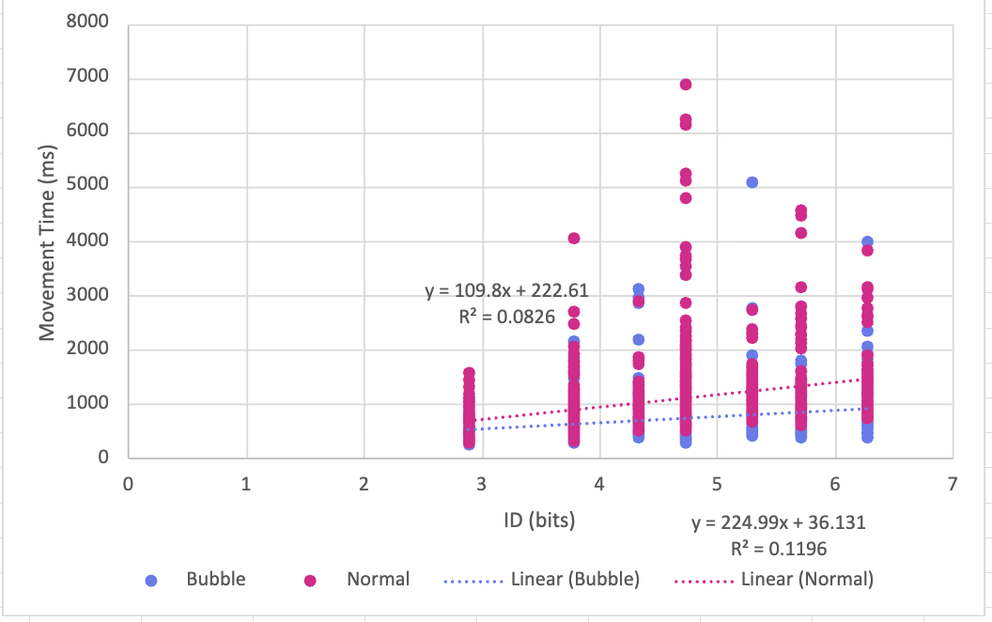

**Conclusion**

The Bubble Cursor was consistently faster, more accurate, and more preferred than the Normal Cursor. Fitts’ Law analysis showed that both the Normal Cursor and Bubble Cursor followed the expected linear trend as shown on the graph, but the Bubble Cursor was less affected by harder conditions such as small or distant targets. These results from this experiment show that the Bubble Cursor can provide a clear improvement for target selection tasks and may be useful in practical applications in human computer interaction where speed and accuracy matter, such as dense user interfaces or small devices.